**AI vs ML vs DL**

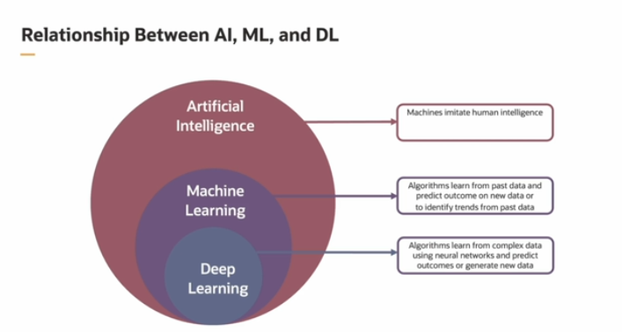

**1. Artificial Intelligence (AI):**

* **What is AI?**
  + AI is a broad field of computer science that focuses on building systems that can **imitate human intelligence**. This includes tasks like understanding language, recognizing images, solving problems, and even decision-making.
  + **AI includes all methods** and techniques that allow machines to perform tasks that would typically require human intelligence.
* **Key Tasks of AI**:
  + Speech recognition (e.g., Siri or Alexa).
  + Image recognition (e.g., facial recognition systems).
  + Decision-making (e.g., recommendation engines, autonomous cars).
* **Key Concept**: AI is the **umbrella term** under which both **Machine Learning** and **Deep Learning** fall. All AI systems try to solve problems that require human-like intelligence, but not all of them use Machine Learning or Deep Learning.
* So basically AI refers to the global term , jisme different AI system ajatay hain some are using ML, DL or GenAI. But yeh mainly target krti hai un capabilities ko jo ek human intelligence ka pass hain.

**2. Machine Learning (ML):**

* **What is ML?**
  + **Machine Learning** is a **subset of AI**. It involves creating algorithms that allow machines to **learn from data** and make predictions or decisions without being explicitly programmed to do so. Iska mtlb hai kay jasay normally toh hum ek system ko jab create krtay hain toh usme kuch rules define krdetay hain using programming toh phr wo system just unhi rules pa work krta hai it does not think out of box BUT jab hum ML system ki bt kr rhay hain toh its mean kay asa system jo experience ka through apnay liya khud hi kuch rules define krta hai and then it work on that rules.
  + The core idea is to use historical data to train a model that can make decisions or predictions when exposed to new data.
* **How it Works**:
  + The machine **learns from data** and improves its performance based on the experience.
  + Example: A spam filter in your email is trained on historical email data. It learns which emails are spam and which are not, and over time, it gets better at filtering out spam.
* **Key Concept**: **ML is a subset of AI**, where the focus is on teaching machines to learn from data. ML uses various algorithms like decision trees, linear regression, and k-nearest neighbors to perform tasks such as classification, prediction, or clustering.
* Ab jo machine learning hai wo specially use hoti hai for performing task like prediction on a given data or analyzing the given and making future predictions, But it is limited to given data. And it work on less data more efficiently as compare to working on large data. And mainly it focus on **classification** and **prediction.**

**3. Deep Learning (DL):**

* **What is DL?**
  + **Deep Learning** is a **subset of Machine Learning**. It focuses on using **neural networks** with multiple layers (hence "deep") to learn from vast amounts of data. Deep learning models are designed to automatically learn the **features** from raw data.
  + Deep Learning models are inspired by how the human brain works, with **artificial neurons** that learn to extract patterns from data.
* **How it Works**:
  + **Neural networks** are made up of layers of artificial neurons that process input data and pass the results to the next layer. These networks can learn highly complex patterns, like understanding images or processing human language.
  + Example: Image recognition systems use deep learning to automatically identify objects in images (e.g., recognizing cats, cars, or faces).
* **Key Concept**: **DL is a more advanced subset of ML** that excels when there is a large amount of data and computational power. DL models learn to extract features and patterns automatically, making them especially useful in tasks like image and speech recognition.
* Now basically jo Deep learning hai wo subset hai ML ka , which means kay mainly yeh be data ko learn krti hai but yeh jo architecture use krti hai that is **Neural networks** with multiple layers , So with the help of this architecture it process complex type of Data like Audio, Image etc . and unlike the ML it learns Vast amount of Data. Or jo neural network hain wo asa nhi kay ML may nhi hain , Ml mabi neural network hain but wo nueral network ko itna extensively use nhi kr rhi But jo DL hai wo base hi neural netwok pa krti hai.

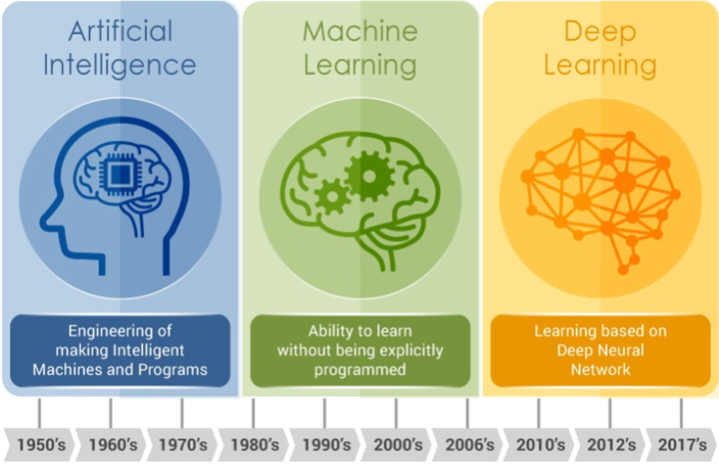

For more info on AI vs ML vs DL : <https://medium.com/analytics-vidhya/ai-ml-dl-whats-what-ecb354967e63>

**Machine learning :**

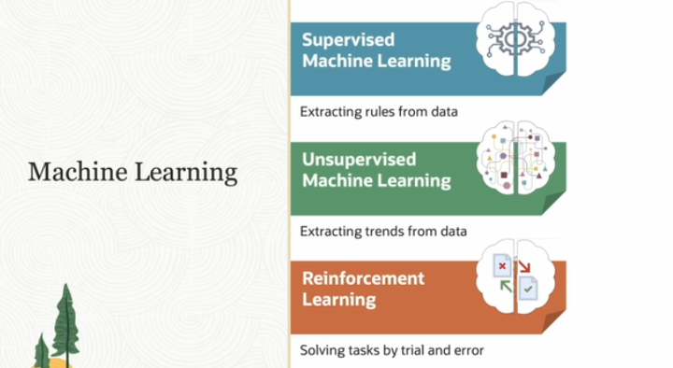

Now there are several types of Machine Learning mentioned in above pic.

**Supervised ML:**

* **Definition**: Supervised learning is a type of machine learning where the model is trained on **labeled data**. The goal is for the algorithm to **learn patterns** from the data to predict outcomes for unseen or new data.
* Or in other words we can also say that the learning in which the model learns under the supervision of data. Imagine you are learning a task under supervision. So, there must be someone who will judge you whether you are getting the right answer. Likewise, in **Supervised Learning,**there’s a set of fully labeled data while training the ML algorithm.

**How Supervised Learning Works:**

1. **Training Data**:
   * The model is provided with a dataset where each input is paired with a **correct output**. This is called **labeled data**. Ab labeled data say mtlb haka ek data already exist krta hai and data jab ML ka model ko dekha diya jaye toh wo data uskay liya ek **labeled data** ban gya hai , like in human you can take Supervise ML like training a small kid , Now let suppose we want to Kid to know about Car , so ab agar ek bachay ko yeh btana haka CAR kisko kehtay hain taka wo later on jab be car jasi vehicle dekhay toh wo easily identify/classify krlay kay this is CAR. toh uskay liya usko Car dekhani be paregi na warna wo kasay understand krega kay Car kya hoti hai . isi tarah say jab hum koi supervise learning ka through model train krtay hain toh jis purpose ka liya wo model build hota hai wo object be usko dekhana hota hai taka wo later on jab be wasa object dekhay toh classify krlay and that object is known as labeled data.
   * For example, if you're building a model to classify images of cats and dogs, the training data would consist of images labeled as "cat" or "dog."
2. **Learning Process**:
   * The model learns the relationship between the input data (e.g., the pixels in an image) and the output labels (e.g., "cat" or "dog").
   * During training, the model adjusts its internal parameters (weights and biases) to minimize the difference between its predictions and the actual labeled output.
3. **Prediction**:
   * After the model is trained, it can be given **unseen data** (data it has not encountered before), and it will use what it learned during training to make predictions.

**Example:**

Let’s say you have a dataset of houses, where each house has information like size, number of bedrooms, and location (input data), and the price of the house (labeled output). In supervised learning:

* **Input**: Size, number of bedrooms, location (features).
* **Output**: Price of the house (label).
* **Goal**: The model learns the relationship between the house features and the price. Once trained, it can predict the price of a new house based on its features.

**Example for understanding supervised ML:**

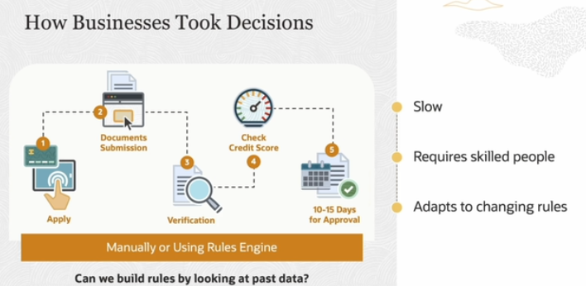

Applying credit card

1. Application for credit card.
2. Document submission
3. Your verification
4. Check your credit
5. Then it take 10-15 days for approval

But who are doing this all ? sometimes it is done by manually or sometime by rules engine But now what are its fallback , these are that as it is slow, requires skilled people, Adapts to changing rules (jo rules change hotay hain unko adapt krna and unki adaption ma time be lgta hai).

So can we build rules by looking at past data which is also known as Labeled data?

So basically we can also consider past data or labeled data as set of examples , which can include like the history of approval credit card in the past. Mtlb kay usme wo sari requirements hongi jo ek credit card ko approve krnay ka liya chaiya So that data will become as Labeled data for our model then we train model in that data so that after training jab be koi new data ayy for approving credit card toh wo usko **classify** krlay hain and then outcome predict like in our case outcome can be like whether give approval of credit card or not. And predicting of outcome is done by regression .

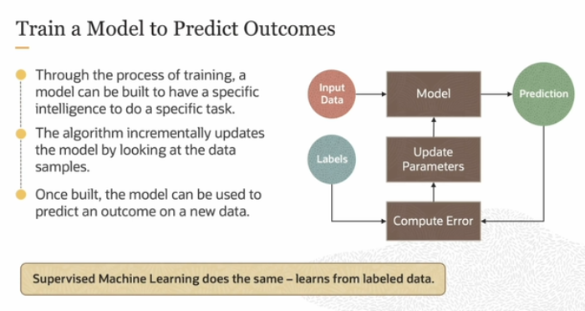

Ab jo agar koi new rules create hon or like jo new data as a input receive that is little bit different from the data that normally get for approving credit card so for that type of data jo Algorithm hota hai wo automatically new rules define krleta hai and parameters ko update krdeta hai , which makes it fast than doing it manually.

**Unsupervised Machine Learning :**

* **Definition**: Unsupervised learning is a type of machine learning where the model is trained on **unlabeled data**. The goal is for the model to **discover patterns, trends, or structures** in the data without any specific guidance or labels.
* Now basically Unsupervised ML ko iss lia introduce kia gya bcuz there are so many domains where data is not in labeled form, Mtlb kay ab agar humay ek Cat classification ka model create krna tha toh uskay liya toh humna ek Cat as a labeled data provide krdi bcuz jo Cat hai wo constant hai wo kabi be change nhi hogi han some minor changes aasktay hain But Cat will remain cat or there are so many other processes jaha par labeled data hota hai like the applying Credit card BUT agar humay ek model create krna hai wo ek ecommerce store may weekly basis or daily basis pa yeh classify krkay btayega kay Which product is high in demand , So in that situation hum usko koi specific dataset toh nhi provide krsktay naa bcuz it depends on trend. So in that case we will use a Unsupervised ML technique.
* In unsupervised ML , mainly we provide the dataset that is not labeled So the model will find the trends and pattern by itself without human intervention. Like let say agar ecommerce store jiskay pass 500 products hain ab usme say pta lagana haka konsi product zeada demand pa hai or zeada sale hui hai or zeada searching may hai . Toh yeh model khud say find krega on the basis of data provided to it. Or yeh trend zarori nhi kay agar aj Glasses trend pa hain toh kl be glasses trend pa hongay toh isi lia model ko jabbe data provide kreinga toh wo on the basis of that data new trend find krkay dega.
* Now jo unsupervised ML hai isme 2 kam hotay hain ek different patterns ko find krna and second jo similar patterns or data ho usko groups or cluster may divide krna.

**How Unsupervised Learning Works:**

1. **No Labeled Data**:
   * Unlike supervised learning, the dataset used in unsupervised learning does **not** have labeled outputs. The model does not know the correct answers or categories for the data.
   * For example, if you have a collection of customer data with their preferences, purchase history, etc., you do not have labels like "high spender" or "low spender"—the model must discover these patterns on its own.
2. **Pattern Recognition**:
   * The model tries to **group** or **cluster** data points based on their similarities or **reduce** the data’s complexity by identifying underlying structures.
   * The model explores the input data to find **natural patterns** without human intervention.

**Key Tasks in Unsupervised Learning:**

1. **Clustering**:
   * **What it does**: Groups data into clusters or groups based on similarity.
   * **Example**: Customer segmentation in marketing, where customers are grouped into segments based on similar purchasing behavior or demographics.
   * **Use Case**: Grouping customers for targeted marketing strategies.
2. **Dimensionality Reduction**:
   * **What it does**: Reduces the number of input variables by identifying the most important features in the data. This helps in simplifying datasets with many variables, such as images or high-dimensional datasets.
   * **Example**: Principal Component Analysis (PCA) for reducing features in large datasets (e.g., compressing images for more efficient processing).

**Example of Unsupervised Learning:**

Imagine you run an e-commerce website and have collected data on your customers' browsing habits, purchase history, and demographics. You don’t have any labels for "best customers" or "occasional shoppers"—the data is unlabeled.

Using **unsupervised learning**, you can:

* **Cluster customers** based on behavior, like grouping frequent buyers together and casual browsers separately.
* **Find hidden patterns**, such as discovering that customers in one region are more likely to buy specific products.

**Applications:**

* **Customer Segmentation**: Finding groups of similar customers for marketing.
* **Anomaly Detection**: Detecting unusual patterns that may indicate fraud or network intrusions.
* **Market Basket Analysis**: Discovering which products are frequently bought together in retail.

**Reinforcement Learning;**

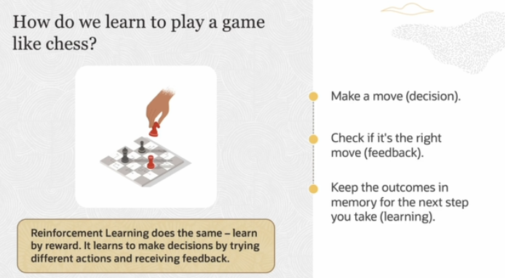

Now basically above picture say hi ye smjh aa raha haka, asi learning jisme ap koi action perform kro and then uskay against jo feedback milay usse learn kro. Now in the above pic person is playing Chess , so it takes a move then it will check the feedback that does he take the right or wrong move ? so then on the basis of feedback agar toh move right hoga toh wobi wo yaad rakhega takay next time wohi move implement kray or agar move wrong toh wo be wo yaad rakhega takay next time wo move na implement kray , So basically it is learning through reward and that type of learning is known as Reinforcement learning .

**Applications of Reinforcement Learning:**

* **Game AI**: Used in games like **AlphaGo** (where the AI learns to play the game better than human experts through reinforcement).
* **Robotics**: Robots learn to perform tasks (e.g., walking, picking objects) by trial and error in a simulated environment.
* **Autonomous Vehicles**: Reinforcement learning can be used to train self-driving cars by learning how to navigate in different conditions through trial and error.
* **Recommender Systems**: Some recommendation systems use reinforcement learning to suggest products based on user interactions.

**Deep learning**

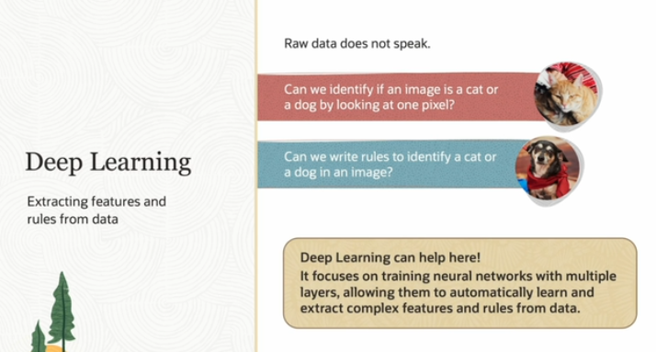

Now what is purpose of Deep Learning ?

So basically you can see the problems in above pic , which can be solved by deep learning. Like we cannot classify/identify Image through single pixels or We cannot define rules for identify Cat or Dog. So now in these type of situation DL come into play.

**Deep Learning (DL) Overview:**

* **Deep Learning** is a subset of machine learning that focuses on **training neural networks with multiple layers**. These layers allow the system to **automatically learn complex features** and patterns from the raw data without manual feature engineering.

**Purpose of Deep Learning:**

The image highlights two key points to demonstrate why Deep Learning is necessary:

1. **Raw Data Cannot Be Interpreted Directly**:
   * **"Raw data does not speak"**: This means that raw data (like images or audio) in its original form is too complex and unstructured to be understood or processed directly by machines.
   * Without deep learning, we can't determine whether an image is of a cat or a dog just by looking at one pixel or some basic data points. A single pixel holds little information about the full picture, which makes manual rule-based approaches impractical.
2. **Manual Rule Writing is Inefficient**:
   * **"Can we write rules to identify a cat or a dog in an image?"**: Writing manual rules for identifying objects in images is nearly impossible because of the complexity of patterns, textures, and variations in images. Each image can have many differences in color, background, and perspective, which makes it hard to design fixed rules for object detection.

**How Deep Learning Solves This:**

* **Automatic Feature Extraction**: Deep Learning allows machines to learn complex rules and patterns **automatically** by training on large datasets. Instead of manually specifying what a "cat" or a "dog" looks like, the neural network learns these features on its own by analyzing thousands or millions of labeled images.
* **Multiple Layers for Hierarchical Learning**:
  + Early layers in the network might detect **basic features** like edges or simple shapes.
  + Deeper layers combine these features to identify more complex patterns, like a dog's face or a cat's ear.
  + The network learns to distinguish between a cat and a dog by focusing on multiple features at different abstraction levels.

**Summary:**

Deep Learning is essential because it allows machines to **automatically learn from data** without requiring humans to write rules or extract features manually. It’s highly effective for complex tasks like image classification, where the system needs to identify objects, patterns, or categories based on a large amount of raw data (images, text, audio, etc.).

**Neural Networks or Artificial Neural Networks (ANNs):**

**Artificial Neural Network(ANN): Artificial Neural Network is the computing system designed to stimulate the way the human brain analyzes and processes information. It is the basis of Artificial Intelligence as it mimics us and solves problems that would prove impossible or difficult for us or statistical standards. ANNs have self-learning capabilities that enable them to produce better results as more data becomes available.**

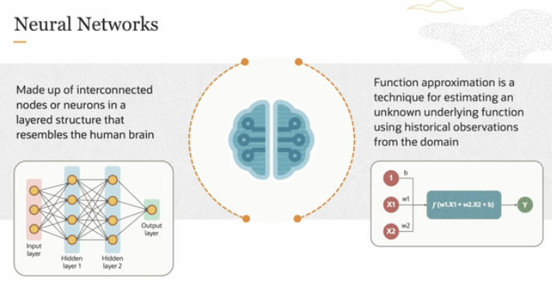

**What is a Neural Network?**

* **Neural networks are made up of interconnected nodes or neurons, structured in layers, similar to how the human brain works. These neurons work together to process data and make predictions.**

**Structure of a Neural Network:**

1. **Input Layer:**
   * **This layer receives the input data. In the image, you can see the input layer on the left side, which feeds data into the neural network.**
   * **Example: For an image recognition task, the input layer could represent the pixel values of an image.**
2. **Hidden Layers:**
   * **These layers sit between the input and output layers. They are called "hidden" because they are not directly visible (i.e., they don’t interact with the outside world).**
   * **Hidden Layer 1 and Hidden Layer 2 in the image represent intermediate layers where computation happens. The neurons in these layers apply mathematical operations on the input data.**
   * **These layers learn patterns from the data by adjusting weights and biases through a process called training.**
3. **Output Layer:**
   * **This is the final layer, where the network produces the output or prediction.**
   * **Example: In an image classification task, the output might be a probability score representing whether the image contains a cat, dog, or other object.**

**Key Concept: Function Approximation:**

* **Function approximation (shown in the image on the right) is a technique where the neural network estimates an unknown function based on historical data or observations.**
* **In a neural network, each connection between neurons has a weight (w), and each neuron may have a bias (b). The output is calculated using a mathematical function. For example:**

**f(w1⋅X1+w2⋅X2+b)=Yf(w1 \cdot X1 + w2 \cdot X2 + b) = Yf(w1⋅X1+w2⋅X2+b)=Y**

* + **X1, X2: Inputs.**
  + **w1, w2: Weights (which determine the importance of each input).**
  + **b: Bias term (used to shift the function to better fit the data).**
  + **Y: The final output or prediction.**
* **The goal of the network is to learn the best values for these weights and biases through training, so the network can accurately predict the output for unseen data.**

**Generative AI:**

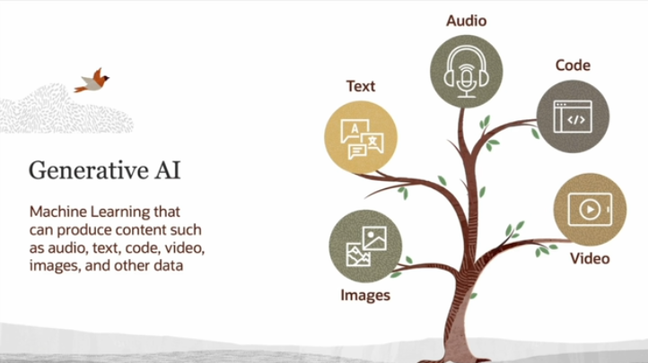

**Definition:**

Generative AI is a branch of **Machine Learning** that is capable of creating new, original content, including:

* **Text**: Like generating written responses, stories, or articles.
* **Audio**: Such as creating new music tracks or synthesizing human-like speech.
* **Code**: Writing computer code, as seen in tools like GitHub Copilot.
* **Images**: Generating images from textual descriptions (e.g., DALL-E).
* **Video**: Creating videos or animations from patterns in existing data.

**How It Works:**

Generative AI models are typically based on **neural networks** that learn patterns from large datasets. After training on these patterns, the model can **generate new content** that resembles the original training data but is completely novel.

1. **Learning from Data**:
   * The models are trained on **huge datasets**. For instance, a model like GPT-3 (used in ChatGPT) is trained on massive amounts of text from books, websites, and other written material.
2. **Creating New Content**:
   * Once trained, the model can take inputs (e.g., a prompt like "write a story about a cat") and generate new, coherent content based on the patterns it learned.
   * This allows the model to generate **text, code, audio, images, or videos** that are creative and often indistinguishable from human-created content.

**Real-World Example:**

* **ChatGPT**: A generative AI model that creates human-like text responses based on user inputs. It’s trained on vast amounts of text data and can generate anything from casual conversation to technical explanations.
* **DALL-E**: A generative AI that creates images from text descriptions, allowing users to generate images by describing what they want.

